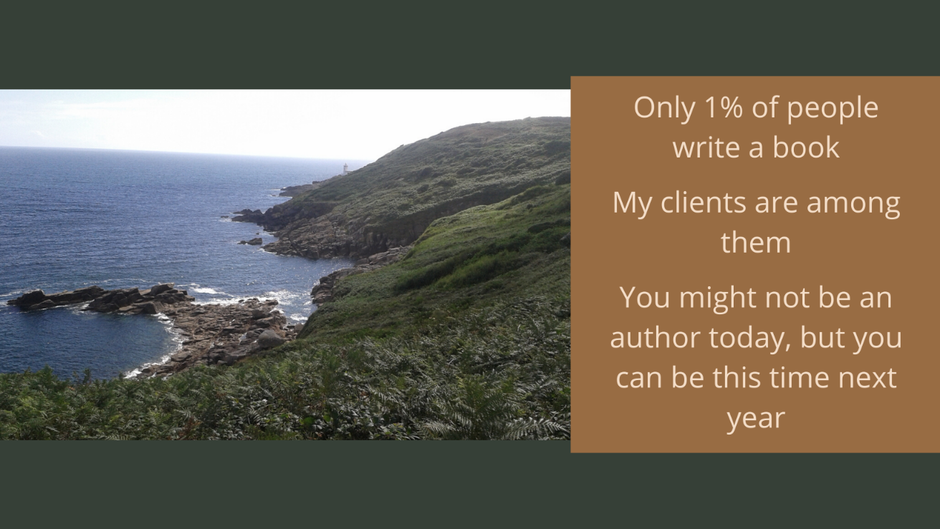

Writing Coaching/Consultation
This service is entirely flexible, adapting easily to your requirements. I offer either weekly 1 hour sessions or twice a month 1 hour sessions. These sessions will continue for as long as you need in order to complete your manuscript, average time is 6-9 months, but it depends entirely on your needs.
Services Include:
Accountability
Developmental editing advice
Coaching
Instruction on Book Writing/Publishing

